Weekday Scheduling Workflow

Here's what the decision tree covers and how it's structured:
Main flow (blue, center)
17 nodes running top to bottom; request received → pre-flight → slot assignment → WA send → delivery check → response monitoring → nudge → call → booking → invite → confirmation → log booked ✓. Each arrow is labeled with the condition that triggers it.
Pre-flight catches 6 conditions before any outreach begins: company and Calendly validity, phone + email, duplicate/already-scheduled check, timezone flag, slot availability, and duplicate requests. This is where Tier 1 edge cases get intercepted before they waste any intern time.
Left column (teal = Tier 3, coral = Tier 2):
- Pre-flight fail → blocked, PM escalates
- Candidate unavailable → Tier 2, log return date
- Explicit decline at response stage → Tier 3, stop all contact
- Intent changed at nudge stage → Tier 3, stop
- Voicemail or decline on call → Tier 3, PM escalates
- System outage / recruiter unresponsive → dashed "any stage" connectors, since these can surface at any point in the flow
Right column (red = Tier 1, coral = Tier 2):
- Not delivered → email fallback (T1)
- Unread 90 minutes → call immediately (T1, via L-path arrow)
- Reply 2 / change → 3 alternates sent (T1)
- Device or firewall blocks Calendly → Shyam books directly (T1)
- Limited slots → flag PM, prioritise (T2)
- Wrong slot booked → Shyam rebooks correct (T1)
- Books then cancels → re-offer once, then log (T2)
Decision nodes (amber)
These are the six branch points where intern behavior diverges based on what actually happened. Each decision box includes a subtitle showing all possible outcomes so interns know what to look for before acting.

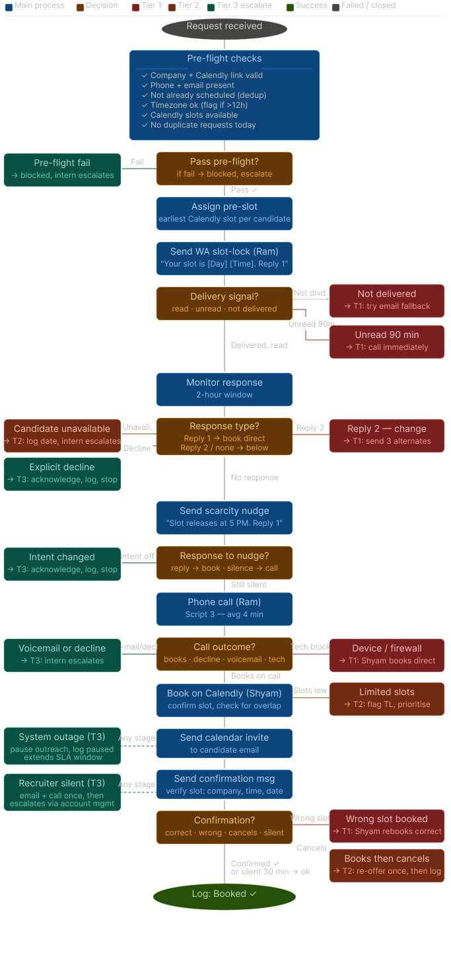
Figma link:
https://www.figma.com/design/kxyrghe79RDu4mv0Pm5c2F/scheduling_decision_tree?node-id=0-1&t=2ZX5VnNCH2Hy9okI-1

